**Problem 1**

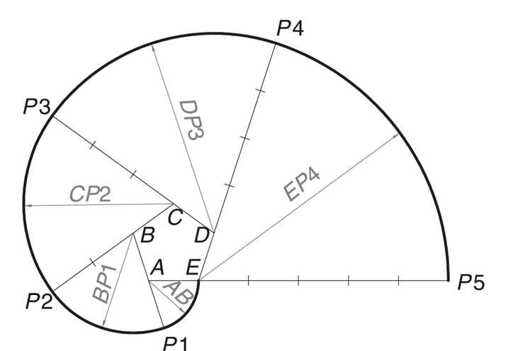

5 x 25 = 125 mm

**Problem 2**

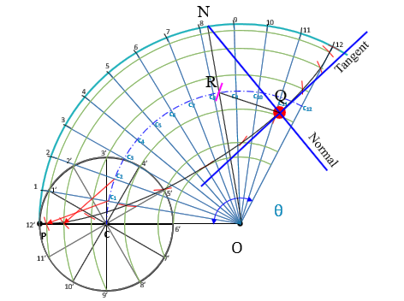

**OP = Radius of directing circle = 100 mm**

**PC = Radius of generating circle = 25 mm**

**θ = r/R x 360º = 25/100 x 360**° **= 90**°

**Problem 3**

OV = ½ of transverse axis = 180 / 2 = 90 mm

VK = Abscissa = 60 mm

MN = Double ordinate = 150 mm

Eccentricity = 4/3 > 1 => Conic is Hyperbola

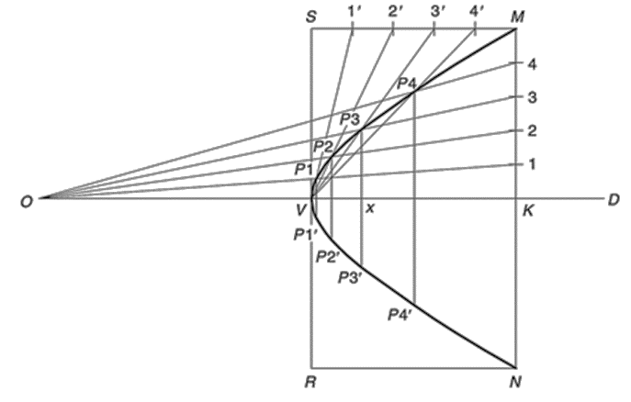

**Problem 4**

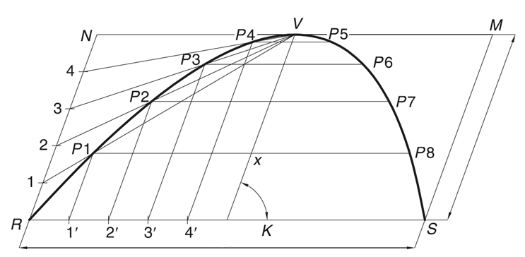

60º

120 mm

40 mm